**December 2017**



**Machine Learning Immersion Day**

*Hands-on with Tensorflow and Jupyter*

Table of Contents

Overview 3

Launching a Jupyter Notebook Server using Amazon SageMaker 4

Accessing the Jupyter Notebook Instance 6

Launching Jupyter Notebooks 6

Terminating the Notebook Instance 8

Conclusion 9

# Overview

TensorFlow is an open source software library for numerical computation using data flow graphs. Nodes in the graph represent mathematical operations, while the graph edges represent the multidimensional data arrays (tensors) communicated between them. The flexible architecture allows you to deploy computation to one or more CPUs or GPUs in a desktop, server, or mobile device with a single API. TensorFlow was originally developed by researchers and engineers working on the Google Brain Team within Google's Machine Intelligence research organization for the purposes of conducting machine learning and deep neural networks research, but the system is general enough to be applicable in a wide variety of other domains as well. This lab is designed to demonstrate how to run the Amazon Deep Learning AMI and will introduce the audience to:

* Stepping through and modifying Jupyter Notebooks
* Hands-on experience with:
  + Tensorflow and Autoencoder Network

# Launching a Jupyter Notebook Server using Amazon SageMaker

1. Sign into the AWS Management Console <https://console.aws.amazon.com/>.
2. In the upper-right corner of the AWS Management Console, confirm you are in the desired AWS region (e.g., N. Virginia).
3. Click on **Amazon SageMaker** from the list of all services. This will bring you to the Amazon SageMaker console homepage.  
   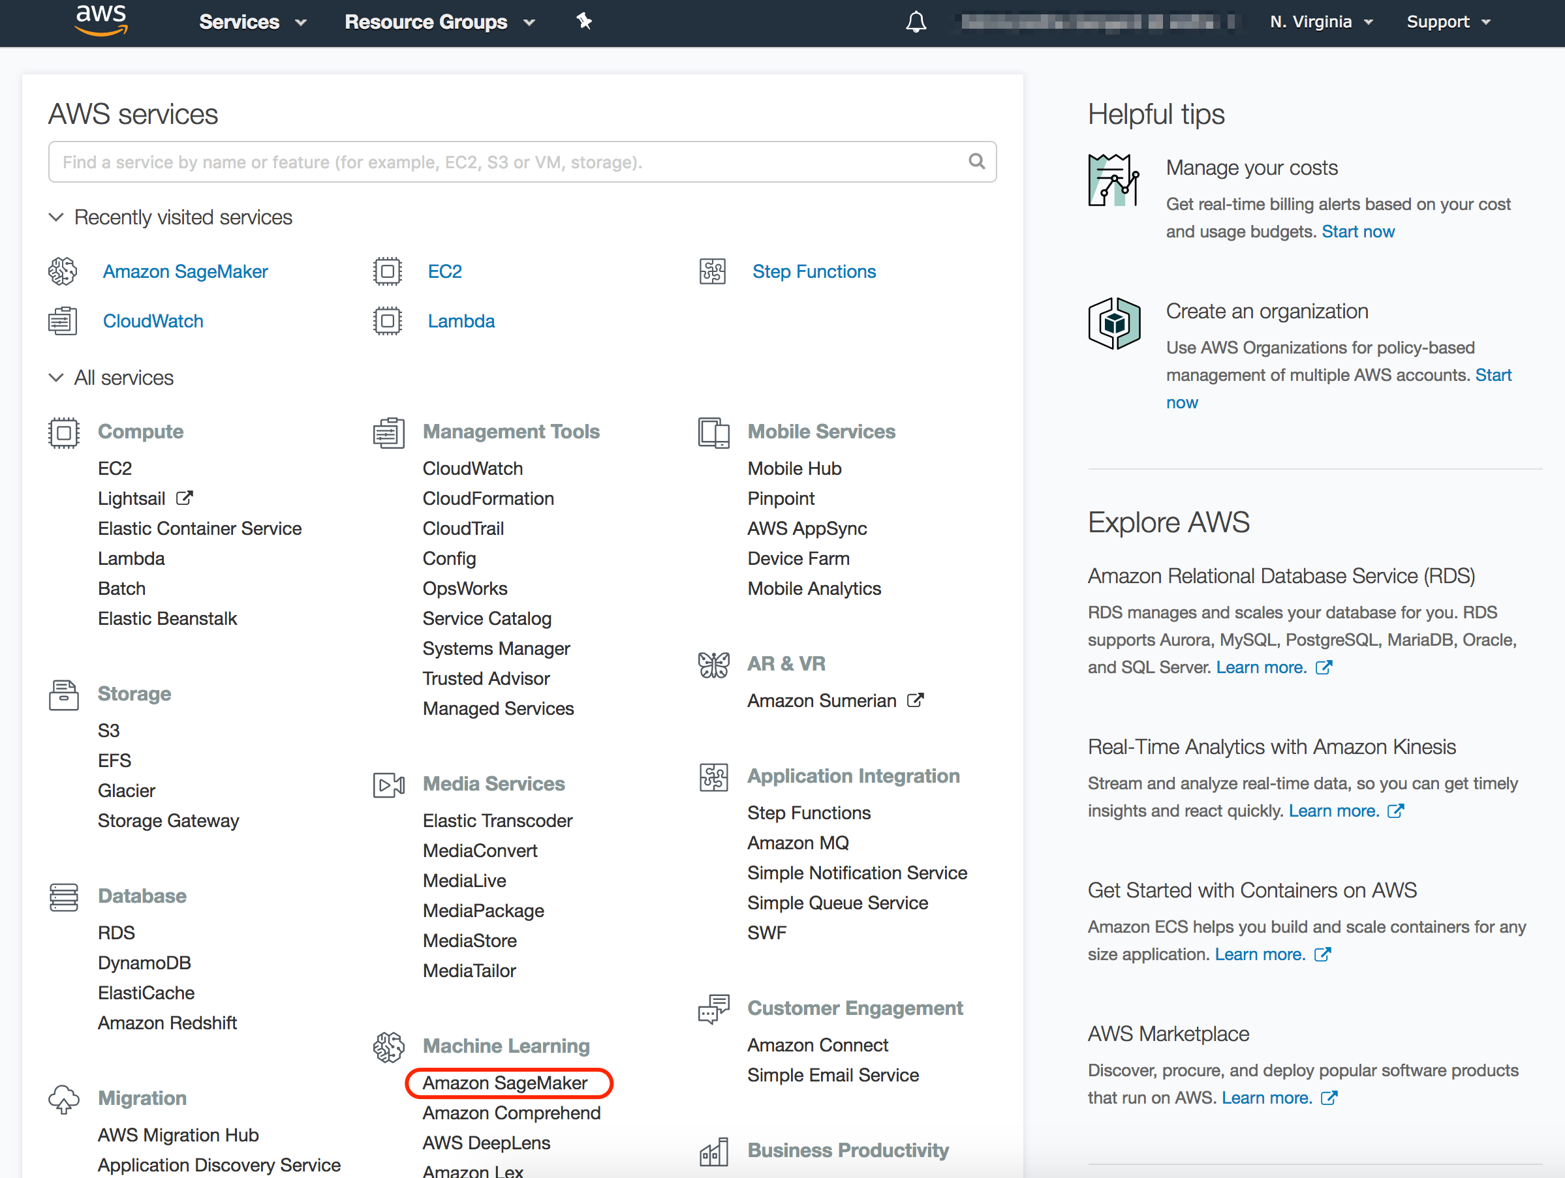
4. To create a new Jupyter notebook instance, go to **Notebook instances**, and click the **Create notebook instance** button at the top of the browser window.  
   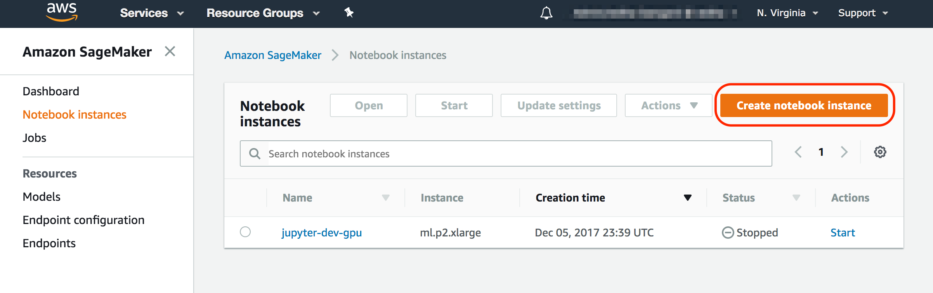
5. Type *[First Name]-[Last Name]-Lab-Server* into the **Notebook instance name** text box, *ml.p2.xlarge* into**the Notebook instance type***.*
6. In the resulting modal popup, choose **Create a new role**, and select *None* under the **S3 Buckets you specify – optional.** Click and **Create role.  
   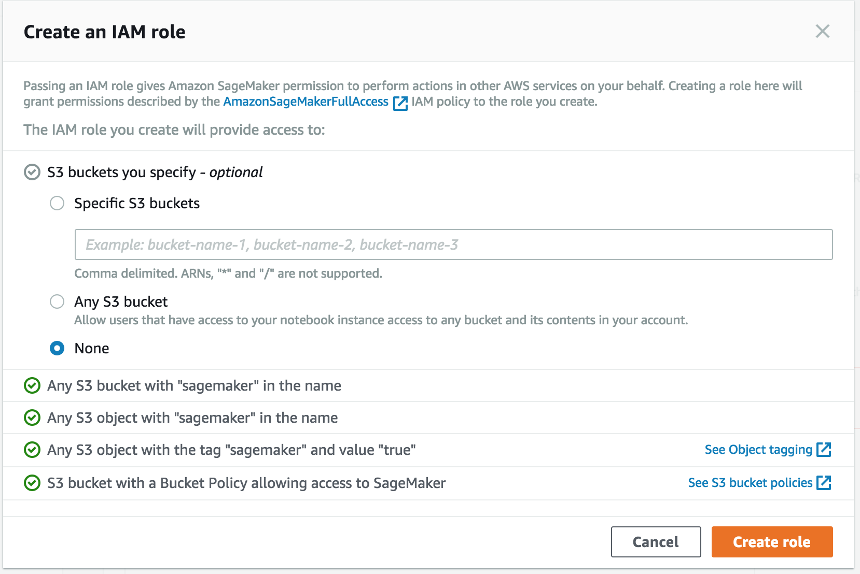**
7. You will be taken back to the **Create Notebook instance** page, click **Create notebook instance.** This will launch a p2.xlarge instance running the Amazon Deep Learning AMI.

# Accessing the Jupyter Notebook Instance

1. Make sure that the server status is **InService**. This will take a few minutes.

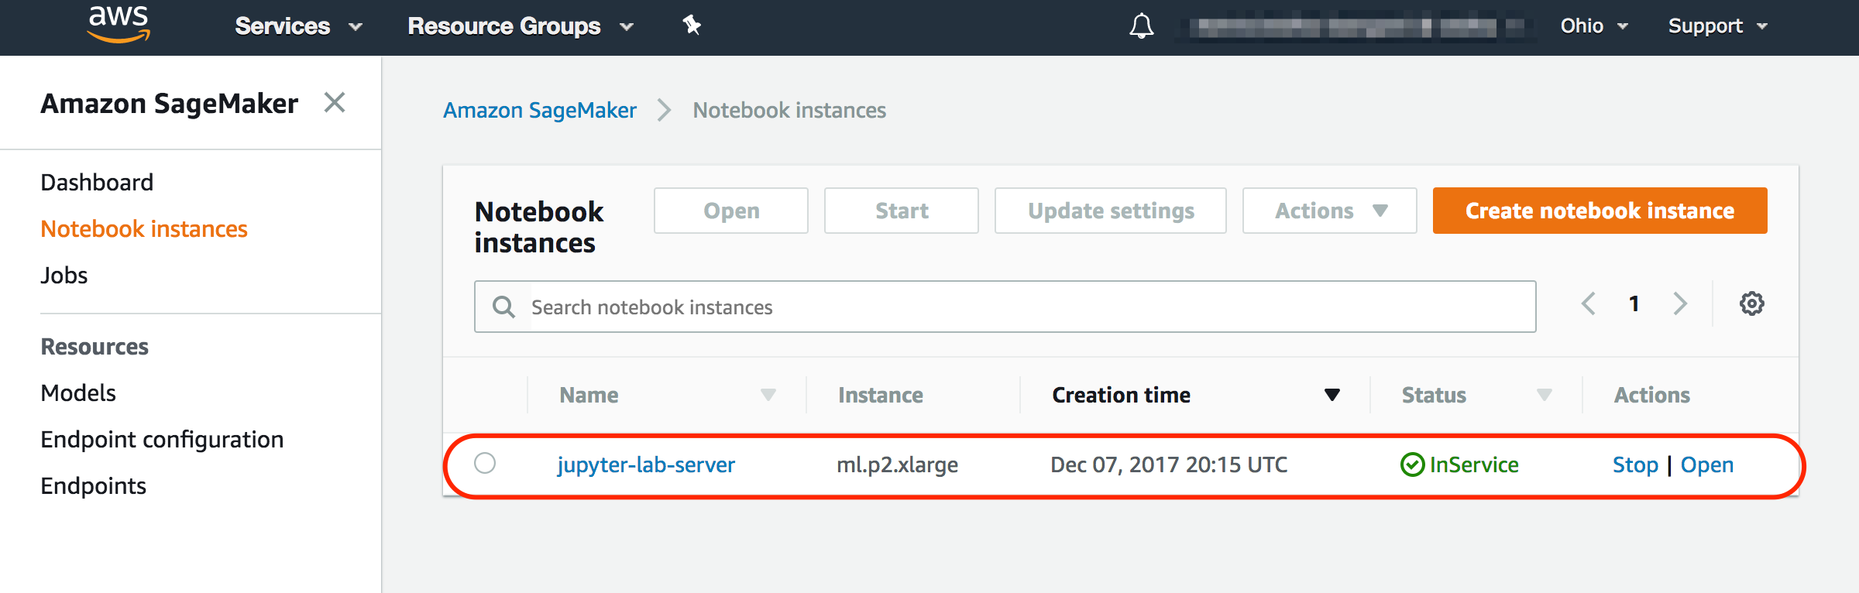

1. Click **Open**. You now have access to the Jupyter Notebok.

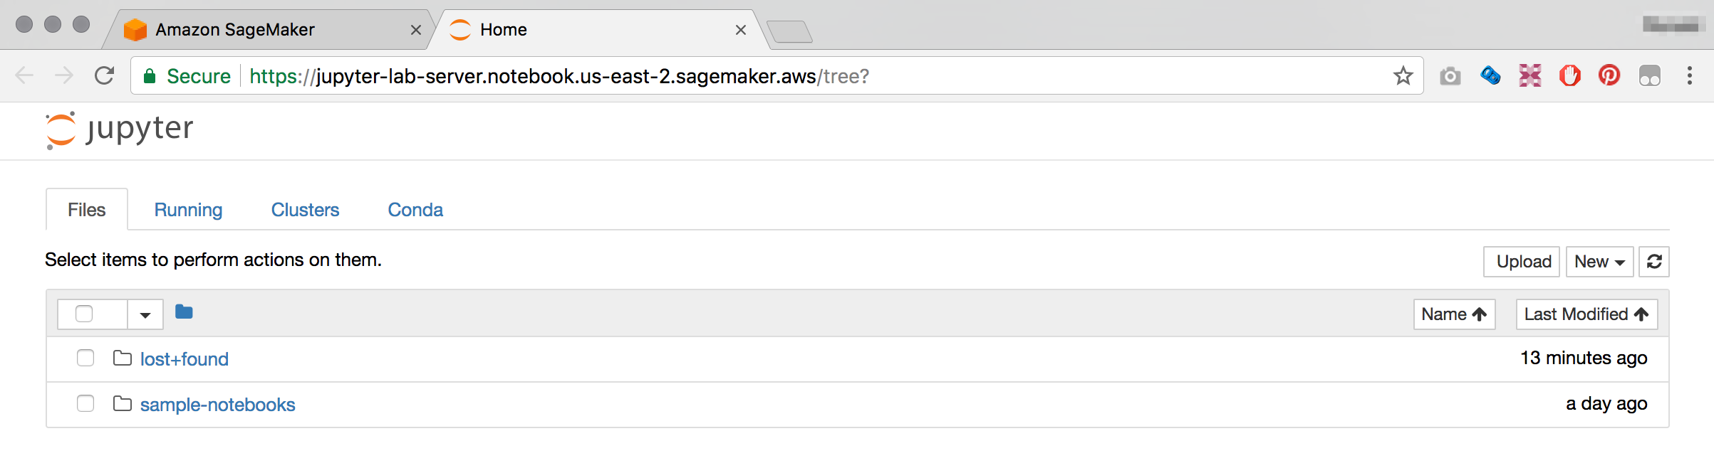

# 

# Launching Jupyter Notebooks

1. We are going to log on to the server by launching a terminal console. Click **New** and select **Terminal.** This will open up the terminal on a new browser tab.

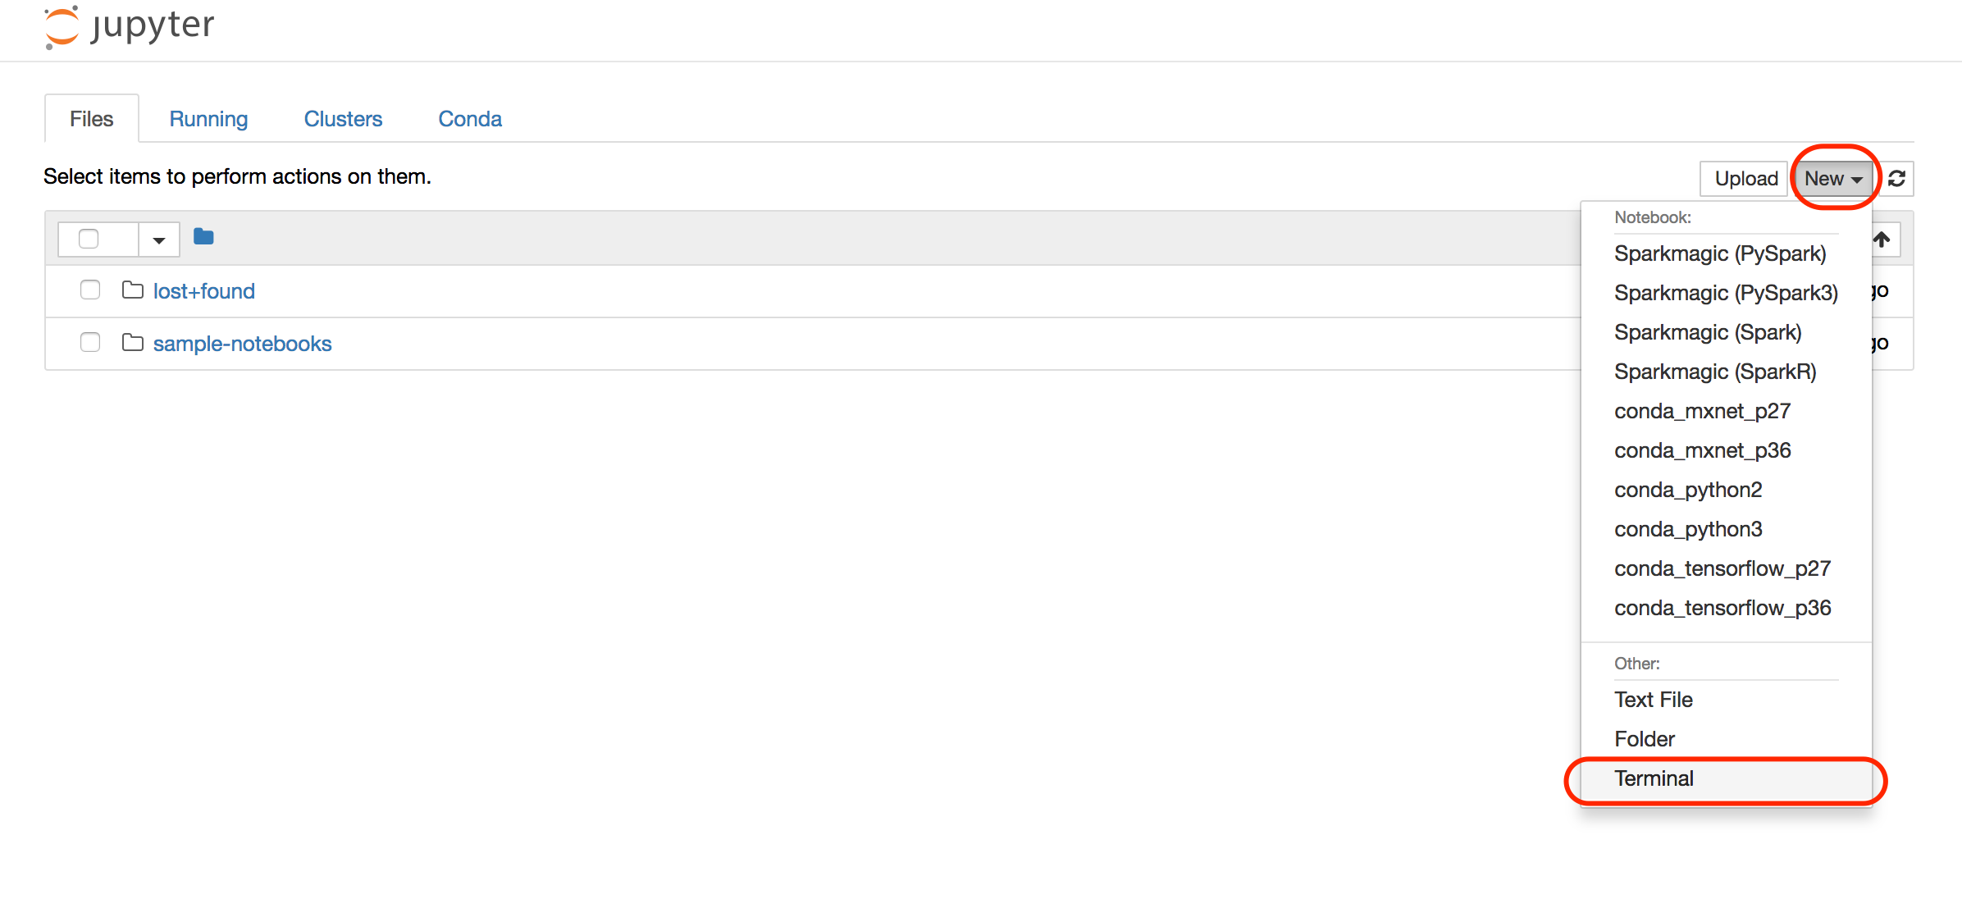

1. To download all the lab files and supporting following command

cd sample-notebooks/

wget https://s3.amazonaws.com/mldayasset.corp.amazon.com/tf_lab/sa_ml_tf_lab.tar.gz

1. Extract the files by typing

tar xf sa_ml_tf_lab.tar.gz

1. Go back to the previous browser tab, and click on **sample-notebooks** and **ml_lab_tensorflow**, you should now see the following 1 notebook:

* FraudDetection_AE_TF.ipynb



1. Click the notebook to start the lab. Instructions continue on the Jupyter interface.
2. If prompted with the following screen, select **conda_tensorflow_p36** from the drop down, and click **Set Kernel**



1. Instructions continue on the Jupyter interface.

# Terminating the Notebook Instance

1. Open the Amazon SageMaker console <https://console.aws.amazon.com/sagemaker/> and click on **Notebook instances**
2. Find the notebook instance listed as *[First Name]-[Last Name]-Lab-Server* and click on the server name
3. Click **Delete** to terminate the Notebook Instance.

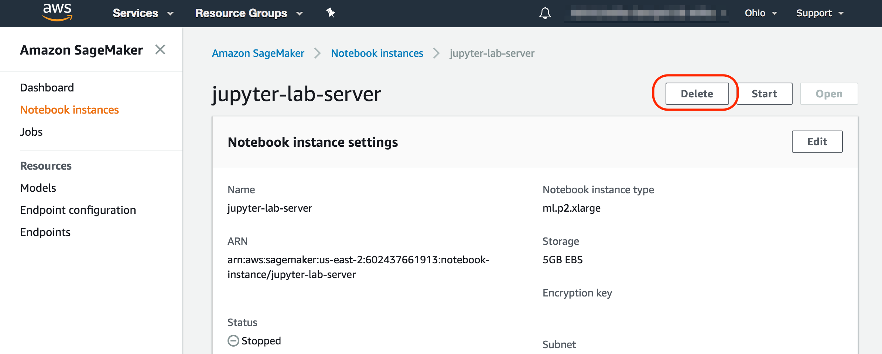

# Conclusion

In this lab you have learned the basic operations to launch the Amazon Deep Learning AMI, run Jupyter Notebooks and step through a TensorFlow notebook.